

RoundTable™ Collaboration Environment

RoundTable Project Server – Installation Guide

Table of Contents
1 Installation 3
1.1 Java Runtime Installation 3
1.2 System Configuration 5
1.3 RoundTable Installation 9
1.3.1 RoundTable License File Installation 11
1.3.2 RoundTable Installation Verification 11

Installation
This section will guide you through the process of preparing your Windows Operating System for RoundTable and installing the RoundTable Project Server. This guide covers the Windows XP family of Operating Systems. However, it should work for the entire family of Windows NT based Operating Systems such as Windows 2000 and Windows Server 2003. If you are installing RoundTable on a different Operating System such as Linux, Macintosh or, another version of Windows, contact your Dommoni Representative to obtain instructions for your target platform.

Java Runtime Installation
RoundTable utilizes the Java Platform, developed and distributed by Sun Microsystems. Java allows RoundTable to be portable and easily run in various operating environments such as Linux or Mac OSX. In order to successfully install and run RoundTable, you will first need to install the Java Runtime and configure your operating system to allow RoundTable to find the JRE. This section walks you through this process.

- First you will need to download the Java Runtime Environment (JRE) Installation executable. This can be obtained from http://java.sun.com. At the time of this writing, the most recent JRE available was version 5.0.02. We recommend downloading that version. If you are not able to access the JRE Installation or are having difficulties finding it, contact your Dommoni Representative and they will be able to help you find it on the Web or send you a copy on CD-ROM.

- Once you have the JRE Installer on the machine you wish to run RoundTable from, click the JRE icon to begin the installation process. You should see a screen similar to the following.
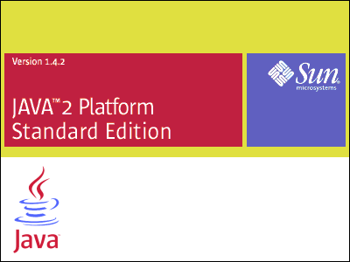

- The JRE Installation will take a moment to initialize. It will then present you with a license agreement. Be sure to read and accept the license agreement.

- Once you have accepted the license agreement, the JRE installer will present you with a list of options to include as well as where you want to install the JRE.
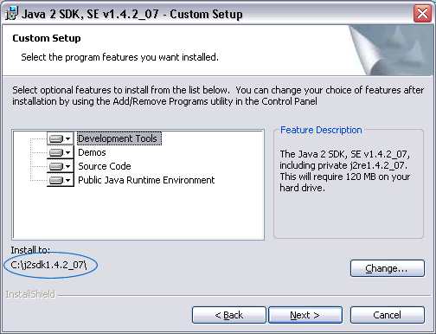
This is an important step. Be sure that the “Public Java Runtime Environment” is selected and make a note of the location that you installed it to, which is highlighted in blue in the above photo.

- Press next to begin the JRE installation.

- Once the installation completes, you will need to configure your Operating System so that RoundTable is able to find the JRE. This is covered in the next section, “System Configuration”.

System Configuration
This section will guide you through configuring your Operating System so that RoundTable is able to find the components you installed in the previous step. This section must be completed correctly for RoundTable to run successfully. At the end of the section, we will run a routine to verify the integrity of the configuration.
- Open your Windows Control Panel and click on the “System” Icon. Then click the “Advanced” Tab. You should see the following window appear.
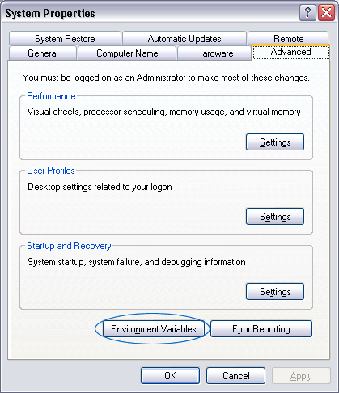
Click on the “Environment Variables” button as indicated above.
Note: If you are running a different variation of Windows, your interface might vary. Please consult your Windows Operating System User Manual.
- Once you click on the “Environment Variables” button, you should see the following window.
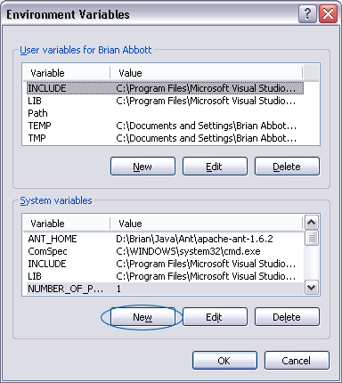
Press the “New” Button in the “System variables” section.

- Once the “New System Variable” Dialog box appears, enter “JAVA_HOME” for the variable name and, enter the root folder of the location where you installed the Java Runtime. For example, if you installed the JRE at the root of C:\, your variable value would be something like “C:\jdk1.5.0_02” depending on which version of the JRE you installed. The dialog, once filled out should appear similar to the following.
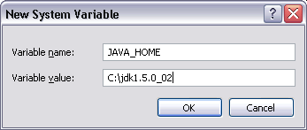

- Once you have created the JAVA_HOME environment variable, view the list of System Variables again to verify JAVA_HOME is present.

- Go back to the list of System Variables. From that list select the “Path” variable and press the “Edit” button. At the beginning of the variable value field for path insert “%JAVA_HOME%\bin;” Be sure to include the percentage signs as well as the semicolon after bin. It should look like the following.
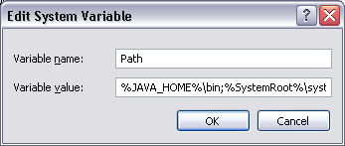
Note: The Java bin directory might not be directly underneath your JRE installation. Please open the JRE folder in Windows Explorer and verify that the bin directory is present. If bin is contained in another directory, you will need to include that directory in the Path as well. Press “OK” to save the changes.

- In order to verify that the system configuration is correct, open your windows command prompt and type “java –version”. You should see a response similar to the following if everything was configured correctly.
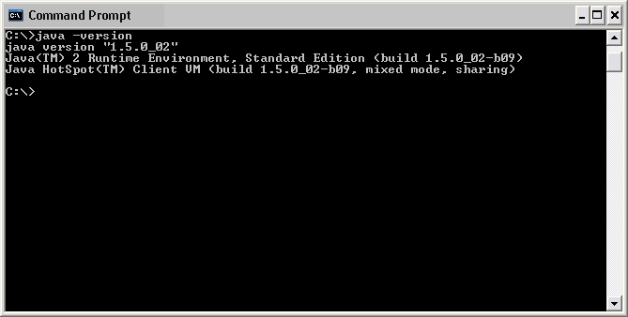
If you should encounter a problem in the Configuration and do not see the message above, contact your Dommoni Representative and they will put you in touch with a RoundTable Technical Support Agent.

RoundTable Installation
This section will complete the RoundTable Installation and verify that it was installed and functioning properly.

- Find and run the RoundTable Setup file. RoundTable Setup will first run a verification routine to ensure the integrity of the file. Once that completes, you will be presented with the installation welcome screen.
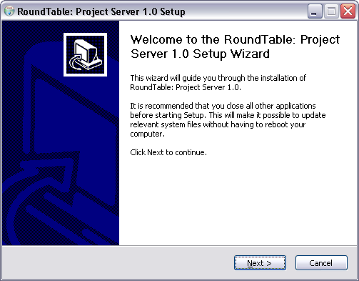

- Follow through the steps presented by the wizard. Read and accept the license agreement to continue the installation.

- When the wizard prompts for the installation path, we suggest you use the default however, you can choose a different location if you like. Once you are ready to begin, press the “install” button. This will start the installation process.
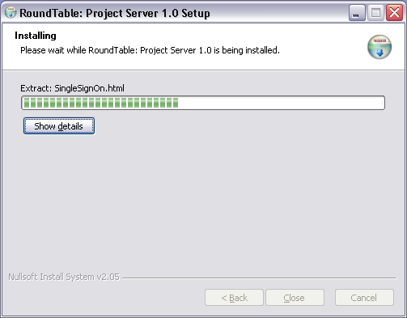

Near the end of the installation you will see the following dialog. It is important that you let this complete and do not interrupt its execution. Once it completes it will automatically close itself.
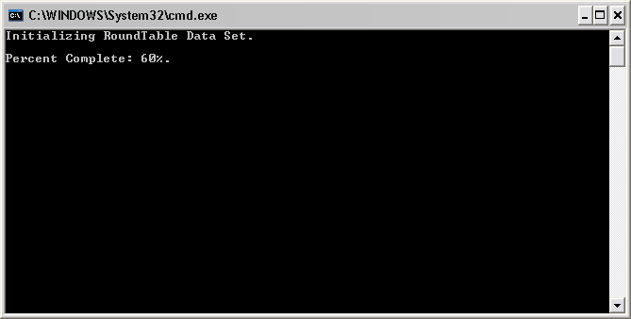

RoundTable License File Installation
In order for the RoundTable server to function properly, you will need to copy your RoundTable license file to the appropriate location. Until the license file is in place, any user that attempts to connect to the server will receive an error. Make sure that RoundTable is currently stopped by viewing the RoundTable entry in the Services Panel. Once it has been stopped, copy your received license file to the “license” directory located underneath your RoundTable Project Server Installation Directory. Restart RoundTable from the Services Panel as shown below.

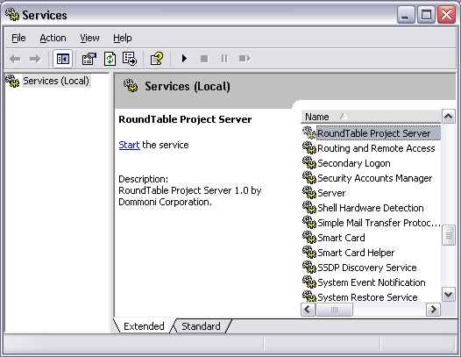

RoundTable Installation Verification
Once you have started the RoundTable Project Server, you will want to verify that everything is running properly and accessible from client applications. Open a standards compliant web browser such as Microsoft Internet Explorer. In the address bar, type the following: http://machinename:8080/WebUI/login.jsp. Where “machinename” is either the name of the machin or IP Address of the machine where you installed RoundTable. You should see the RoundTable Login Page when you connect.
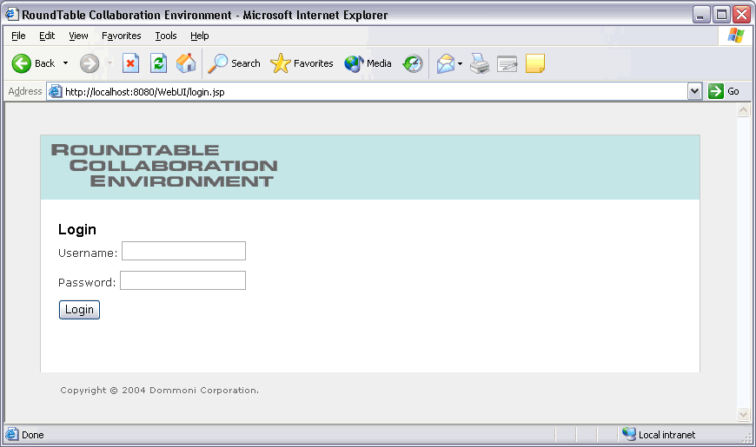

In order to login to an un-configured installation, the default username and password you will need to use is as follows:
Username: “administrator”
Password: “dommoni”

Entering that information will allow you to login as the Administrative user to a new installation and begin configuring your system. The following sections will walk you through the various aspects of RoundTable administration.

